GDP:

1. find more recent data to merge into one file

2. City-level economic data

Inflation:

1. More recent index + by quarter

2. Other types of indexes other than CPI

Vehicle fleet

1. Category and Region breakdowns by year - longer time span

Q: Why is this relevant?

Others sources?

Mid-income data

Unemployment

…

Goal → Gather a complete dataset to add to the resource list - upload to Snowflake

Q: what are we going to do with them?

Meixi:

Other relevant indicators

Econ conditions:

GDP per capita -2022–world bank

Inflation:

* GDP deflation - 2022–world bank
* HICP - all items - annual average indices – 2023–Eurostat
* Comparative Price levels –2023 Eurostat

Household:

* Disposable income net lending net borrowing –2022 – OECD Stats
* Annual net earnings -2022 -Eurostat
* Tax rate–2022 - Eurostat

Labor Force

* Unemployment by sex and age – 2022 - Eurostat
* Labor Market slack by sex and age – Eurostat

Other

* Social welfare expenditure –2021–eurostat
* Mean Expenditure per household per adult –2022-Eurostat

Note: I only downloaded data from the most recent 5 years (up till data latest date), if correlation analysis will need to create a doc with a longer timeline. Really depends on timeframe of snowflake data, but I’m having trouble loading it

Brainstorm:

* Not most recent data: first look for correlation, then manually update data with most relevance
* Correlation btw stats and:
  + Amount default% ($default/$Total transaction)
  + # default rate (# defaults/# transactions)

Kris

IMF: <https://www.imf.org/external/datamapper/profile/CHL>

Banco central chile: <https://si3.bcentral.cl/siete/ES/Siete/Cuadro/CAP_CCNN/MN_CCNN76/CCNN2018_P0_V2?cbFechaInicio=1997&cbFechaTermino=2023&cbFrecuencia=QUARTERLY&cbCalculo=NONE&cbFechaBase=>

GDP:

1. Updated Data - International Monetary Fund - excel - GDP_Data_Merged_1980-2028 - IMF

2. API option: (Is it necessary/worth trying?) - IMF

<https://www.imf.org/external/datamapper/api/help>

<https://datahelp.imf.org/knowledgebase/articles/1968408-how-to-use-the-api-python-and-r>

3. GDP in pesos - Banco central chile

Inflation & Other indicators:

Inflation Rate (1980-2028, year) - IMF

CPI (1998-2024, month) - banco central chile

Other

Unemployment Rate (1980-2028, year) - IMF

City Level Data:

SANTIAGO - Urban and Cities Platform of Latin America and the Caribbean <https://plataformaurbana.cepal.org/en/node/117>

GDP_Santiago (2013-2022, year) - banco central chile <https://www.bcentral.cl/web/banco-central/areas/estadisticas/estadisticas-regionales-rm#rm>

Economic Indicators (2014-2023, year, month also available) - banco central chile

unemployment rate https://www.ceicdata.com/en/chile/unemployment-rate-gran-santiago/unemployment-rate-gran-santiago#:~:text=Chile%20Unemployment%20Rate%3A%20Gran%20Santiago%20data%20was%20reported%20at%207.400,Feb%202023%2C%20with%20222%20observations.

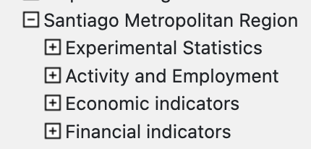

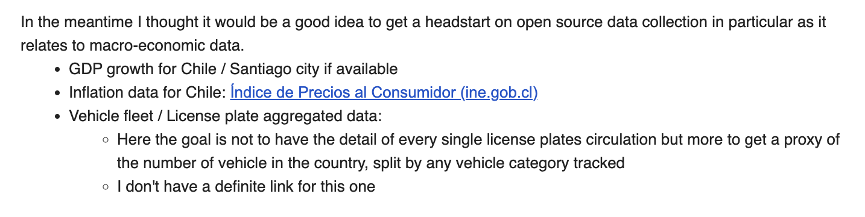

GDP

* Gross GDP, current price (pesos, USD, ppp)
* GDP per capita
* GDP growth rate
* City level

Labor Conditions:

* Unemployment

Inflation:

* CPI
* GDP Deflator
* Inflation Rate
* PPP conversion rate
* Transportation cost index (ICT)
* City level

Household:

* Disposable income net lending net borrowing –2022 – OECD Stats
* Household debt, all instruments –IMF

Vehicle Info

* Driver liscences (by region, total #) - INE
* City level

API:

* IMF
* Trading Economics